Redirection of pipes

1. Create a file name error_log in your current directory. Suppose you do not have any file named aa11 in your current directory.
A)How can you redirect the error message to the file error_log when we apply the command "wc -l aa11" ?
ANSWER:

B)How can you ensure that all the error log are appended to the error_log file?
ANSWER:
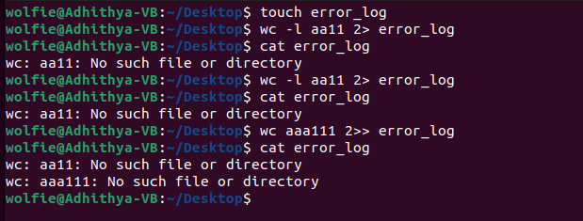

2. Create files named test1, test2, testa, testb
How can you count the number of files starting with test and then having only one digit in their name using only a single line command ?

ANSWER:
